Arapai: An Offline-First Large Language Model Architecture for AI-Assisted Learning
with Adaptive Response Levels in Low-Connectivity Educational Environments
Joseph Walusimbi*, Ann Move Oguti, Joshua Benjamin Ssentongo, Keith Ainebyona
Department of Electronics and Computer Engineering
Soroti University, Soroti, Uganda
Emails:
2401600068@sun.ac.ug*, amoguti@sun.ac.ug, 2401600236@sun.ac.ug, 2401600230@sun.ac.ug
*Corresponding Author
Artificial intelligence (AI) and large language models (LLMs) are increasingly transforming educational technology by enabling conversational tutoring, personalised explanations, and inquiry-driven learning support. However, most AI-powered educational systems rely on continuous internet connectivity and cloud-based computation, limiting their deployment in bandwidth-constrained educational environments.
This paper presents Arapai, an offline-first large language model architecture designed for AI-assisted learning in low-connectivity educational settings. The system performs all inference locally using quantised language models and incorporates automatic hardware-aware model selection to enable deployment on low-specification, CPU-only devices. By eliminating reliance on external cloud infrastructure, Arapai provides curriculum-aligned explanations and structured academic support through natural-language interaction.
The system was deployed in secondary and tertiary institutions operating under limited-connectivity conditions and it was evaluated across four dimensions: technical performance, usability, perceived response quality, and educational impact. Results indicate stable operation on legacy hardware, acceptable response times for typical instructional queries, and positive user perceptions regarding support for self-directed learning.
These findings demonstrate the feasibility of offline large language model deployment for infrastructure-resilient AI-assisted education in low-connectivity environments.
Keywords: Offline AI, Large Language Models, AI in Education, Edge AI Deployment, Low-Connectivity Environments, Digital Inclusion, Educational Technology

1. Introduction
The rapid advancement of artificial intelligence (AI), particularly large language models (LLMs), has significantly expanded the capabilities of educational technology. These systems enable conversational tutoring, personalised explanations, and adaptive learning support, providing learners with opportunities for inquiry-driven exploration and independent study. Recent studies highlight the potential of AI-powered educational systems to provide formative feedback, scaffold reasoning, and support differentiated learning across diverse subject domains (Holmes et al., 2019; UNESCO, 2021). As education systems increasingly transition toward learner-centred pedagogies, AI-assisted tutoring tools are becoming an important component of modern digital learning environments.
Despite these developments, the practical deployment of AI-assisted learning systems remains uneven across global educational contexts. In many education systems, particularly in developing regions, limited connectivity and high data costs remain persistent barriers to the adoption of advanced digital learning technologies. As AI becomes increasingly integrated into global education systems, the ability to deploy AI-assisted learning tools in infrastructure-constrained environments is emerging as a critical challenge for equitable access to educational innovation. Most contemporary AI chatbot platforms rely on continuous internet connectivity, cloud-based computation, and modern hardware infrastructure. These design assumptions limit their applicability in bandwidth-constrained and resource-limited environments where reliable connectivity and high-performance computing resources are not consistently available (World Bank, 2020; UNESCO, 2023). In many regions, particularly in developing educational systems, intermittent connectivity, high data costs, and legacy computing infrastructure create barriers that prevent institutions from adopting cloud-based AI learning tools at scale.
This limitation is particularly significant as many education systems transition toward competency-based curricula that emphasize critical thinking, problem-solving, creativity, and independent learning (Musimenta, 2023). Such pedagogical models require instructional tools capable of providing iterative explanations, guided reasoning, and learner-driven inquiry. AI tutoring systems are well suited to support these goals, yet their reliance on cloud infrastructure creates a mismatch between technological potential and infrastructural feasibility in low-connectivity contexts.
Recent research in educational technology and artificial intelligence has begun exploring alternative deployment paradigms, including edge-based and locally executed AI systems. These approaches aim to reduce latency, improve data privacy, and enable AI functionality in environments where connectivity is unreliable (Kim & Kim, 2020). However, empirical evidence regarding the deployment of AI tutoring systems in bandwidth-constrained educational settings remains limited (Baillifard et al., 2023). Many existing implementations continue to assume stable internet access and modern computational infrastructure.
This paper addresses this gap by presenting Arapai, an offline-first large language model architecture designed for AI-assisted learning in low-connectivity educational environments. Unlike most AI tutoring platforms that depend on cloud-hosted models, Arapai is designed to operate entirely offline, enabling AI-assisted learning in environments where connectivity is unreliable or unavailable. The system performs all inference locally using quantised large language models and includes a hardware-aware model selection mechanism that enables deployment on low-specification, CPU-only computing devices.
By treating infrastructure constraints as primary design parameters rather than secondary limitations, the system demonstrates how modern AI capabilities can be adapted to operate within the realities of low-connectivity educational environments.
Through eliminating dependence on continuous internet connectivity, Arapai aims to expand access to AI-supported learning in institutions where infrastructure limitations would otherwise prevent adoption.
The central research problem addressed in this study is therefore: how can AI-assisted tutoring systems be designed to operate reliably in bandwidth-constrained educational environments without dependence on continuous internet connectivity or cloud-based computation?
This study makes three main contributions:
- Arapai, an offline-first large language model architecture designed for AI-assisted learning in low-connectivity educational environments.
- A hardware-aware adaptive model selection mechanism that enables quantised large language models to operate on heterogeneous CPU-only systems.
- A real-world pilot deployment evaluation demonstrating the technical feasibility and usability of offline AI tutoring systems in bandwidth-constrained educational institutions.
Through this architecture, the study proposes an infrastructure-resilient approach to AI-assisted learning that complements cloud-based educational AI systems while expanding access to AI-supported instruction in low-resource educational contexts.

2. Related Work
Research on AI-driven educational technologies has evolved from early Intelligent Tutoring Systems (ITS) toward modern conversational AI systems capable of supporting interactive learning. Traditional ITS research focused on learner modelling, adaptive feedback, and personalised instruction based on student knowledge states (Woolf, 2010). These systems demonstrated measurable improvements in structured learning domains such as mathematics and language learning by providing targeted instructional support and iterative feedback mechanisms (Luckin et al., 2016). However, many early systems were domain-specific and required significant authoring effort to construct knowledge representations and instructional pathways.
The emergence of modern large language models has expanded the capabilities of AI-supported learning environments beyond domain-specific tutoring. Contemporary AI chatbots can generate natural language explanations, provide step-by-step reasoning support, and respond to diverse academic queries across multiple subject areas. Recent studies highlight the potential of these systems to support inquiry-based learning, metacognitive development, and self-directed study (Holmes et al., 2019; Kasneci et al., 2023). Systematic reviews of AI applications in higher education similarly identify conversational AI as a promising tool for personalised learning assistance and formative feedback (Zawacki-Richter et al., 2019).
Despite these advances, the majority of current AI chatbot platforms rely on centralised cloud infrastructure for model execution. Cloud-based architectures allow access to large-scale computational resources and continuously updated models but assume stable internet connectivity and modern hardware environments. This reliance creates barriers to deployment in many educational settings where connectivity is intermittent, bandwidth is limited, or operational costs are prohibitive (World Bank, 2020; UNESCO, 2023). As a result, the benefits of AI-assisted learning remain unevenly distributed across global education systems.
Recent work has begun exploring edge-based and locally executed AI architectures as alternatives to fully cloud-dependent systems. Running models locally can reduce latency, improve data privacy, and enable operation in connectivity-constrained environments. Studies indicate that meaningful educational support can still be achieved with smaller or quantised models when system design aligns with hardware constraints and pedagogical objectives (Kim & Kim, 2020). However, empirical deployments of locally hosted AI tutoring systems remain relatively limited, particularly within bandwidth-constrained educational contexts (Baillifard et al., 2023; Strielkowski et al., 2024).
Within this emerging research landscape, Arapai is positioned not as a replacement for cloud-based AI tutoring platforms but as a complementary deployment paradigm. By prioritising offline operation, hardware-aware model selection, and infrastructure resilience, the system addresses a gap between the pedagogical potential of AI-assisted learning and the infrastructural realities of low-connectivity educational environments.

3. System Architecture and Methodology
3.1 System Overview
Arapai is an offline-first AI chatbot system designed for deployment in bandwidth-constrained and infrastructure-limited educational environments. Once installed, the system operates entirely without internet connectivity, allowing continuous access to AI-assisted learning tools in institutions where network infrastructure is unreliable or unavailable.
The architecture performs all core operations locally, including language model inference, response generation, and session management. The system follows a modular design consisting of five main components: user interaction, hardware capability assessment, model selection, local inference, and response adaptation. This architecture allows the system to adapt to heterogeneous hardware environments while maintaining stable offline operation.
Figure 1 illustrates the high-level architecture of Arapai, highlighting the interaction between hardware-aware model selection, local inference, and response adaptation components.

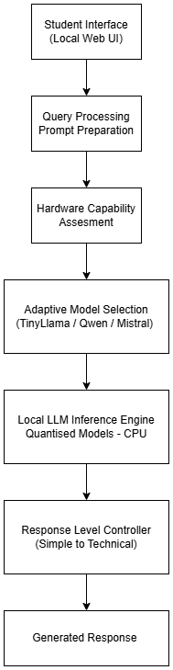
Figure 1: High-level architecture of Arapai

3.2 Hardware and Software Environment
Arapai is designed to operate on commonly available desktop and laptop computers without requiring specialised hardware accelerators such as GPUs or TPUs. All model inference is executed locally on CPU-only systems, enabling deployment on legacy institutional hardware typically found in secondary and tertiary educational environments.
To balance instructional capability with hardware constraints, the system employs a tiered model architecture consisting of three pre-trained quantised large language models. A lightweight model supports low-resource environments, a mid-sized model provides structured reasoning for moderate hardware configurations, and a larger model enables deeper instructional responses on higher-capacity systems. This approach allows the system to adapt its computational requirements to available hardware while maintaining stable offline operation.
Arapai utilises several quantised language models selected for their balance between reasoning capability and computational efficiency, including TinyLlama-1.1B-Chat (TinyLlama Team, 2023), Qwen2.5-3B-Instruct (Qwen Team, 2024), and Mistral-7B-Instruct (Mistral AI, 2024). The model tiers and their corresponding hardware profiles are summarised in Table 1.
Table 1: Model Tiers Used in Arapai’s Adaptive Model Selection Mechanism
Tier | Model | Parameters | Quantised Format | Approx. RAM Required | Typical Hardware Profile | Instruction Depth | Intended Use Case
Tier 1 (Lightweight) | TinyLlama-1.1B-Chat | 1.1B | GGUF (4-bit quantised) | 2–3 GB | Low-spec CPU-only systems (4–8 GB RAM) | Basic explanatory responses | Simple queries, foundational concepts, entry-level instruction
Tier 2 (Mid-Range) | Qwen2.5-3B-Instruct | 3B | GGUF (4-bit quantised) | 4–6 GB | Mid-range CPU systems (8–12 GB RAM) | Structured reasoning, moderate depth | Secondary-level explanations, structured problem solving
Tier 3 (Advanced) | Mistral-7B-Instruct | 7B | GGUF (4-bit quantised) | 8–12 GB | Higher-capacity CPU systems (16 GB+ RAM) | Deeper reasoning, technical detail | Advanced explanations, technical subjects

3.3 Implementation and Deployment
The system is implemented as a locally deployable executable application designed for standard Windows-based computers. A modular software structure separates the user interface, inference engine, and model resources, enabling maintainability and extensibility across deployments.
User interaction is handled through a locally hosted web-based interface accessed through a standard browser. Backend inference is executed through a local runtime environment capable of running quantised large language models without hardware acceleration. Deployment is performed within an isolated software environment to ensure consistent operation across different institutional systems.
To support document-aware responses, Arapai integrates a lightweight retrieval-augmented generation mechanism that allows locally stored educational documents to be incorporated into generated responses. After installation, all interactions occur fully offline. System updates can be performed by adding or replacing model files within predefined directories without requiring changes to the application code.
Figure 2 illustrates the offline deployment and update cycle.
3.4 Response Level Control
Arapai provides configurable pedagogical response levels to accommodate different educational stages. The system supports four explanation levels: Simple English, Lower Secondary, Upper Secondary, and Technical.
Lower explanation levels emphasise simplified vocabulary and intuitive descriptions, while higher levels incorporate progressively more formal terminology, structured reasoning, and subject-specific language. This mechanism enables differentiated instructional support and allows the system to adapt explanation depth to learner needs and curricular expectations.
3.5 Session Management and Performance Optimisation
To improve runtime efficiency, the system maintains the selected language model in memory throughout active sessions. Conversation history can be cleared independently without unloading the model, avoiding repeated model initialisation overhead and improving response latency for subsequent interactions.
Document-grounded querying is supported through locally stored reference materials that can be accessed during response generation. This separation between conversational context management and model lifecycle control follows established best practices in local language model deployment.
3.6 Adaptive Model Selection
Because target deployment environments vary widely in computational capacity, Arapai incorporates an automatic hardware-aware model selection process during system initialisation. The system evaluates available system resources and selects the most appropriate model tier from locally stored options, balancing response capability with hardware feasibility.
The model selection framework prioritises reliable execution on heterogeneous CPU-based systems rather than maximising model complexity. Figure 3 illustrates the conceptual process through which Arapai adapts model selection to available hardware resources.
3.7 Interaction Workflow
Students interact with Arapai through a text-based conversational interface supporting natural-language academic queries. The system generates structured responses that prioritise clarity, step-by-step reasoning, and readability.
In classroom settings, instructors can incorporate the system as a supplementary instructional tool to support competence-based learning outcomes while maintaining existing curricular frameworks. Figure 4 presents the interaction workflow from user query to response generation.
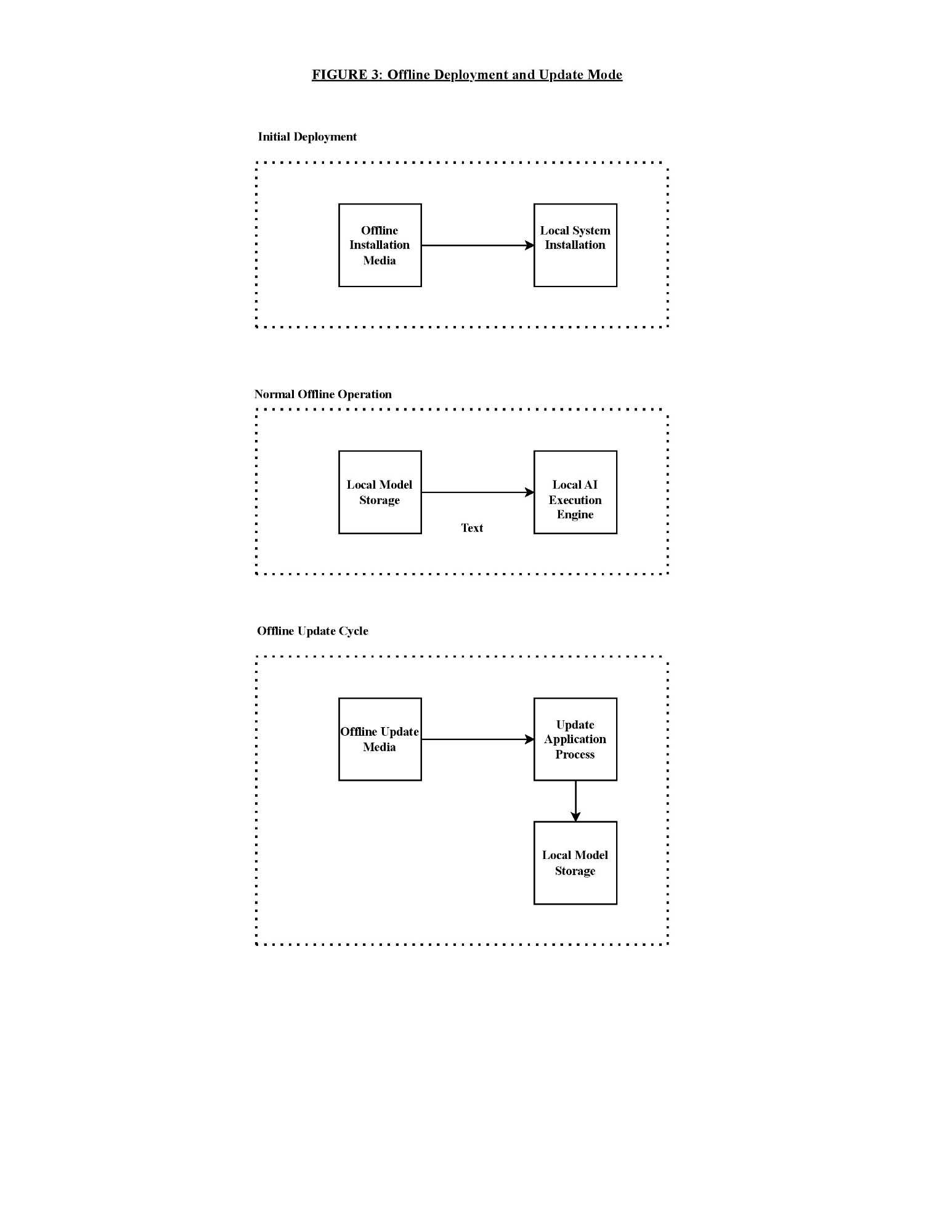  Figure 2: Offline deployment and update cycle | 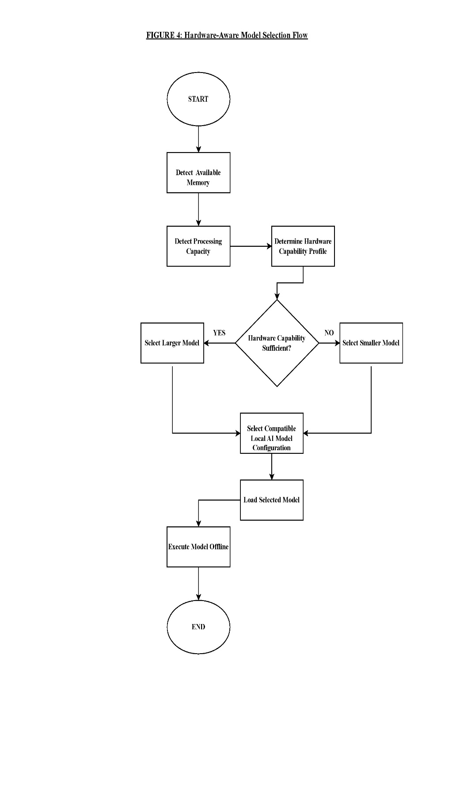  Figure 3: Model Selection Process | 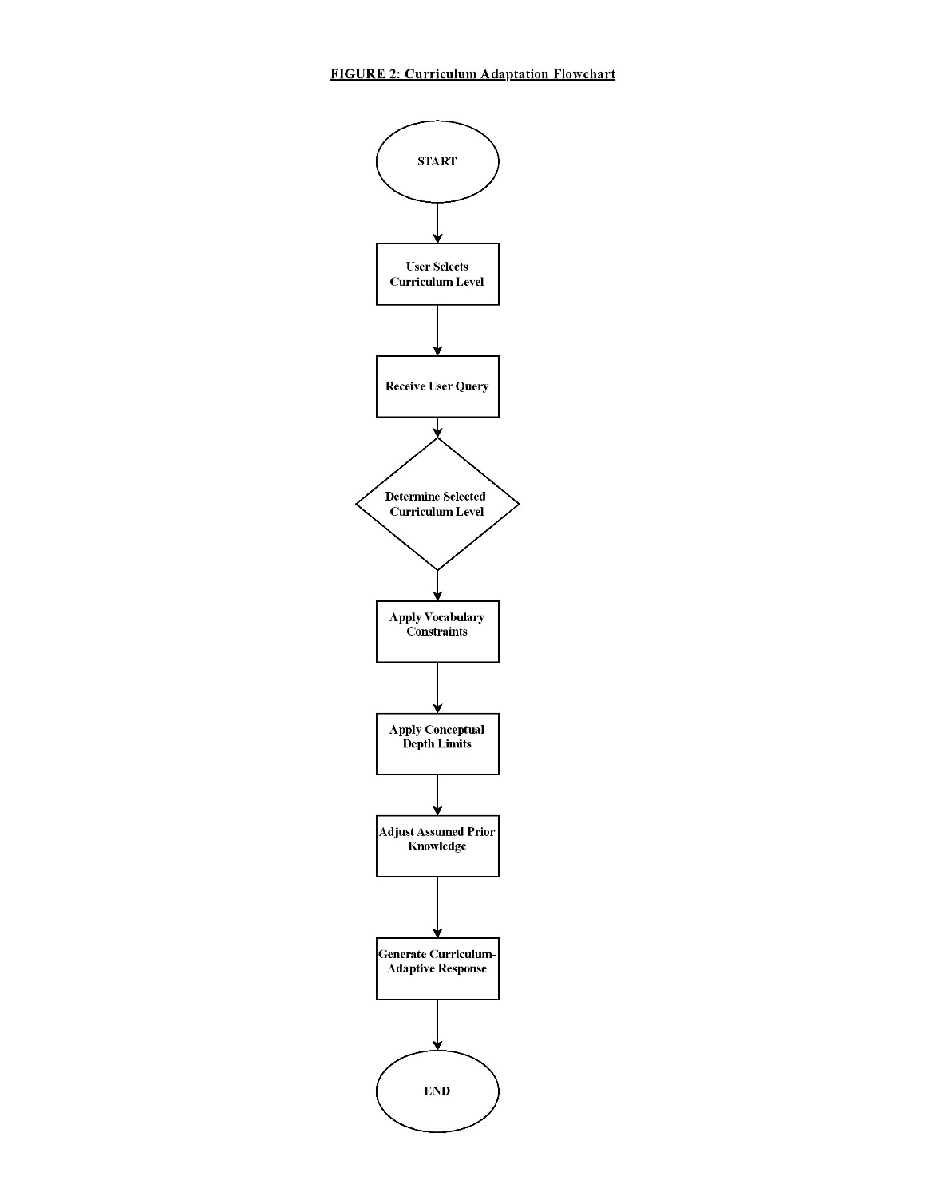  Figure 4: Adaptive Interaction Workflow

4. Results
Arapai was evaluated through a pilot deployment in selected secondary and tertiary educational institutions operating under limited-connectivity conditions. The pilot deployment involved 120 students and 9 instructors across 4 educational institutions. The evaluation focused on four dimensions: technical performance, system usability, response quality, and perceived educational impact. Evidence was gathered through system runtime logs, observational usage data, and user feedback collected during practical use. Because Arapai operates using pre-trained language models without task-specific training, evaluation focused on system-level behaviour and user experience rather than traditional machine learning metrics such as accuracy or loss.

4.1 Technical Performance on Low-Specification Devices
The pilot deployment demonstrated stable operation on the low-specification computing devices commonly available within participating institutions. Core system functions, including model loading, inference execution, and response generation, operated reliably without requiring internet connectivity or external computational infrastructure.
The automatic model selection mechanism allowed Arapai to adapt to different hardware configurations, selecting the most suitable model tier during system initialisation. This ensured that systems with limited memory resources could still support basic instructional queries while more capable machines could provide deeper explanatory responses.
Runtime profiling logs indicated expected inference behaviour for CPU-only execution environments. The system recorded timing information for model loading, prompt evaluation, token sampling, and response generation during operational use. These observations confirm that locally hosted quantised models can operate effectively within the hardware constraints typical of many educational institutions.
Table 2: Observed Performance Characteristics of Arapai During Pilot
Metric | Observation | Notes
Model execution environment | CPU-only systems | No GPU acceleration required
Typical response latency | 1–3 seconds | For short instructional queries
Maximum observed latency | ~43 seconds | For long prompts requiring extended generation
Model loading time | Few seconds depending on model size | Models remain resident in memory during sessions
Hardware compatibility | 4–16 GB RAM systems | Automatic model tier selection
Connectivity requirement | None | Fully offline after installation

4.2 System Usability Evaluation
System usability was evaluated by analysing response latency, task completion behaviour, and user satisfaction during realistic interaction scenarios. For typical instructional queries, response times ranged between 1 and 3 seconds, enabling conversational interaction during classroom or self-study use.
More complex prompts requiring longer reasoning chains resulted in higher latency, with maximum observed response times approaching 43 seconds in extreme cases. This behaviour reflects known computational characteristics of transformer-based language models when executed entirely on CPU-only systems.
Response latency distributions are illustrated in Figure 5, which highlights the relationship between prompt complexity and response time. While longer responses introduce delays, the majority of interactions fell within acceptable response ranges for educational use.
User satisfaction was assessed using a five-point Likert-scale questionnaire administered during the pilot deployment. The majority of responses indicated positive perceptions of the system’s usability and instructional value. Lower satisfaction ratings were primarily associated with longer response delays for complex prompts rather than difficulties interacting with the system itself. Overall user satisfaction results are presented in Figure 6.
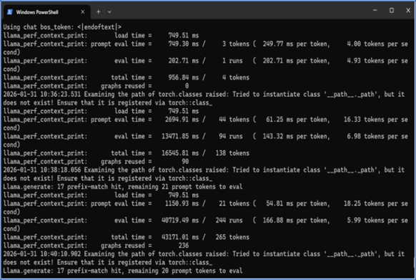  Figure 5: Complexity and Response time relationship | 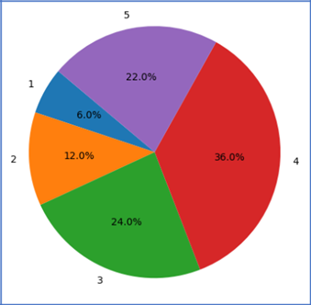  Figure 6: User satisfaction results

4.3 Hands-on User Experience
Qualitative feedback from students and teachers indicated that the system required minimal onboarding and could be used intuitively through natural-language interaction. The browser-based interface allowed users to begin interacting with the system immediately without technical training.
Teachers reported that Arapai functioned as a low-disruption supplement to classroom instruction, particularly in settings where connectivity constraints previously limited access to online educational tools. Generated responses were generally perceived as well-structured and readable, supporting student comprehension of academic concepts.
To accommodate different learning levels, Arapai provides responses with varying degrees of explanatory depth. Figures 7-10 presents example outputs generated by the system across different instructional levels, demonstrating how explanations evolve from simplified descriptions to more technically detailed responses while maintaining conceptual clarity.

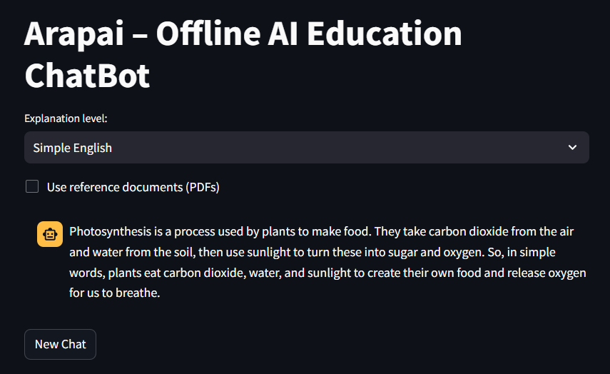  Figure 7: Simple response |   Figure 8: Lower secondary response
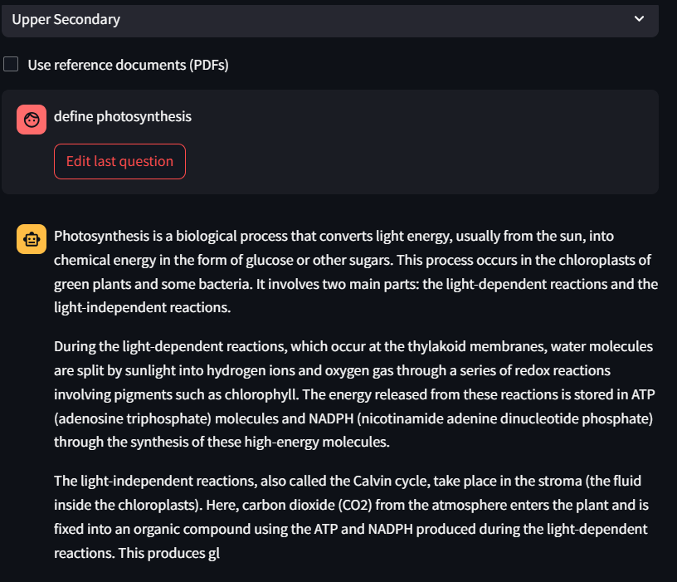  Figure 9: Upper Secondary response | 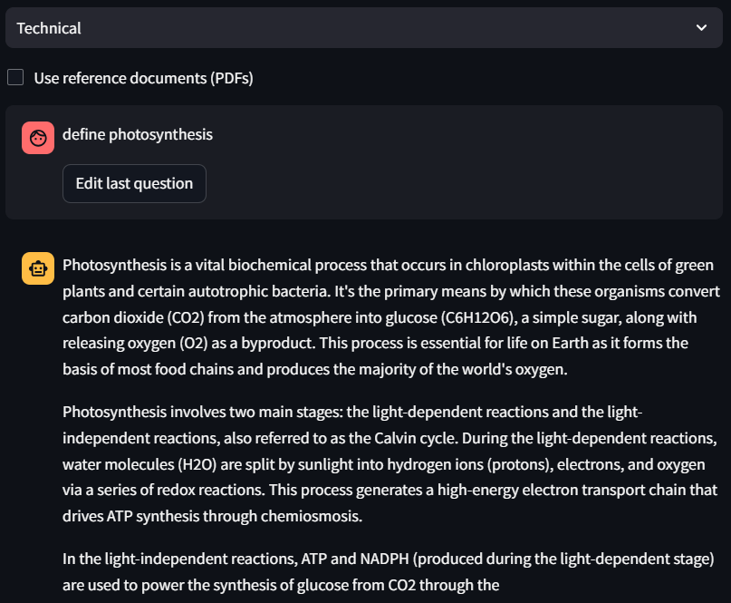  Figure 10: Technical response

4.4 Educational Impact and Learner Confidence
Participants reported that regular access to an offline AI tutoring system encouraged self-paced exploration of course material. Students indicated that the system reduced hesitation in asking questions and allowed them to revisit explanations multiple times during independent study.
Teachers observed that the availability of AI-generated explanations supported competence-based learning approaches by extending instructional assistance beyond the classroom environment. While the pilot deployment did not attempt to measure causal learning gains, the observations suggest that offline AI tutoring systems can positively influence learner engagement and confidence when integrated into existing educational practices.
4.5 Summary of Findings
Overall results from the pilot deployment indicate that Arapai can operate reliably in low-resource educational environments while providing meaningful instructional assistance. The system demonstrated stable technical performance on CPU-only devices, acceptable response times for most instructional interactions, and positive user perceptions regarding usability and learning support. These findings suggest that offline-first AI tutoring architectures represent a viable approach for extending access to AI-assisted learning in bandwidth-constrained educational contexts.
5. Discussion
The pilot deployment of Arapai provides insight into the feasibility of offline-first AI tutoring architectures in bandwidth-constrained educational environments. Rather than positioning the system as a disruptive replacement for existing digital learning tools, the results suggest that locally deployed language models can function as a practical complement to conventional classroom instruction. The system’s ability to generate structured explanations and adapt response depth across educational levels supports pedagogical approaches aligned with competency-based and inquiry-driven learning models.
These findings are particularly relevant in educational contexts transitioning toward curricula that emphasise critical thinking, problem solving, and independent learning (Musimenta, 2023). Such pedagogical frameworks benefit from tools that allow students to repeatedly explore concepts, ask follow-up questions, and engage in self-directed study. The availability of an offline AI tutor provides learners with continuous explanatory support outside traditional classroom interactions while preserving the central role of teachers in guiding learning processes.
From a technological perspective, the study demonstrates that useful AI-assisted learning interactions can occur without continuous cloud connectivity. Although cloud-based AI platforms provide access to larger models and frequent updates, their dependence on stable internet infrastructure limits adoption in many educational environments. Arapai illustrates an alternative deployment paradigm in which locally hosted, quantised language models provide infrastructure-resilient access to AI-supported learning tools.
However, the system also presents several limitations. First, locally deployed models have inherent constraints in reasoning depth and domain-specific expertise compared with larger cloud-based models. Second, the evaluation relied primarily on qualitative feedback and usage observations rather than controlled measurements of learning outcomes. Third, the system currently operates as a standalone instructional support tool and is not yet integrated with formal learning management systems or assessment platforms.
Despite these limitations, the results highlight the potential of offline-first AI architectures to expand access to educational AI technologies in low-connectivity contexts. Rather than viewing offline AI as a reduced alternative to cloud-based systems, it can be understood as a complementary deployment strategy designed for environments where connectivity, cost, and infrastructure reliability remain limiting factors.
Compared with cloud-based AI tutoring platforms, the Arapai architecture prioritises availability, cost predictability, and infrastructure independence. While cloud-hosted models may offer higher reasoning capability and continuous updates, offline-first systems provide an operational advantage in environments where connectivity, cost, and infrastructure reliability remain limiting factors. This complementary relationship highlights the importance of deployment-aware AI system design when extending educational technology to infrastructure-constrained contexts.
6. Conclusion
This paper presented Arapai, an offline-first large language model architecture designed to support AI-assisted learning in bandwidth-constrained and infrastructure-limited educational environments. Unlike most AI chatbot systems that rely on continuous internet connectivity and cloud-based computation, Arapai performs all inference locally using quantised large language models and hardware-aware model selection. This approach enables the system to operate on low-specification, CPU-only devices while remaining independent of external cloud infrastructure. This work demonstrates that modern AI learning assistants can be deployed in infrastructure-constrained environments using locally executed large language models, potentially expanding access to AI-assisted learning across underserved educational systems.
A pilot deployment in secondary and tertiary educational institutions demonstrated that the system can operate reliably on legacy hardware and provide meaningful instructional support through natural-language interaction. Observations from system logs and user feedback indicate that the architecture achieves acceptable response times for typical educational queries and supports learner engagement through structured explanations and adjustable response depth.
The study contributes an alternative deployment paradigm for AI-assisted learning systems by demonstrating the feasibility of offline large language model deployment in low-connectivity educational settings. By decoupling educational AI tools from assumptions of continuous connectivity, Arapai provides a pathway toward infrastructure-resilient and context-aware educational technology. Future work will focus on larger-scale deployments, deeper curriculum integration, and longitudinal evaluation of learning outcomes.

References
Baillifard, A., Gabella, M., Lavenex, P. B., & Martarelli, C. S. (2023). Implementing learning principles with a personal AI chatbot: A case study. arXiv. https://doi.org/10.48550/arXiv.2309.13060
Bloom, B. S. (1984). The 2 sigma problem: The search for methods of group instruction as effective as one-to-one chatbot. Educational Researcher, 13(6), 4–16.
Holmes, W., Bialik, M., & Fadel, C. (2019). Artificial intelligence in education: Promises and implications for teaching and learning. Center for Curriculum Redesign.
Kasneci, E., et al. (2023). ChatGPT for good? On opportunities and challenges of large language models for education. Learning and Individual Differences, 103, 102274. https://doi.org/10.1016/j.lindif.2023.102274
Kim, W.-H., & Kim, J.-H. (2020). Individualized AI chatbot based on developmental learning networks. IEEE Access, 8, 27927–27937. https://doi.org/10.1109/ACCESS.2020.2972167
Luckin, R., Holmes, W., Griffiths, M., & Forcier, L. B. (2016). Intelligence unleashed: An argument for AI in education. Pearson Education.
Mistral AI. (2024). Mistral-7B-Instruct-v0.2 [Large language model]. Hugging Face. https://huggingface.co/TheBloke/Mistral-7B-Instruct-v0.2-GGUF
Musimenta, M. K. (2023, March 15). Competency-based curriculum: A magic bullet for skilling youths in Uganda? STiR Education. https://stireducation.org/competency-based-curriculum-a-magic-bullet-for-skilling-youths-in-uganda/
Qwen Team. (2024). Qwen2.5-3B-Instruct [Large language model]. Hugging Face. https://huggingface.co/Qwen/Qwen2.5-3B-Instruct-GGUF
Strielkowski, W., Grebennikova, V., Lisovskiy, A., Rakhimova, G., & Vasileva, T. (2024). AI-driven adaptive learning for sustainable educational transformation. Sustainable Development, 33, 1921– 1947. https://doi.org/10.1002/sd.3221
TinyLlama Team. (2023). TinyLlama-1.1B-Chat-v1.0 [Large language model]. Hugging Face. https://huggingface.co/TheBloke/TinyLlama-1.1B-Chat-v1.0-GGUF
UNESCO. (2021). AI and education: Guidance for policymakers. United Nations Educational, Scientific and Cultural Organization. https://www.unesco.org/en/articles/ai-and-education-guidance-policy-makers
UNESCO. (2023). Global education monitoring report 2023: Technology in education—A tool on whose terms? United Nations Educational, Scientific and Cultural Organization. https://doi.org/10.54676/UZQV8501
World Bank. (2020). Remote learning, distance education and online learning during the COVID-19
pandemic: A resource list. World Bank Group.
https://documents1.worldbank.org/curated/en/160271637074230077/pdf/Remote-Learning-During-

COVID-19-Lessons-from-Today-Principles-for-Tomorrow.pdf

World Bank. (2022). Digital connectivity and education in Sub-Saharan Africa. World Bank Group.
Woolf, B. P. (2010). Building intelligent interactive chatbots: Student-centered strategies for revolutionizing e-learning. Morgan Kaufmann.

Zawacki-Richter, O., Marín, V. I., Bond, M., & Gouverneur, F. (2019). Systematic review of research on artificial intelligence applications in higher education. International Journal of Educational Technology in Higher Education, 16, 39. https://doi.org/10.1186/s41239-019-0171-0

